**Project Design Phase-II**

**Data Flow Diagram & User Stories**

|  |  |
| --- | --- |
| Date | 27 June 2025 |
| Team ID | LTVIP2025TMID31912 |
| Project Name | Health AI: Intelligent Healthcare Assistant Using IBM Granite |
| Maximum Marks | 4 Marks |

**Data Flow Diagram**

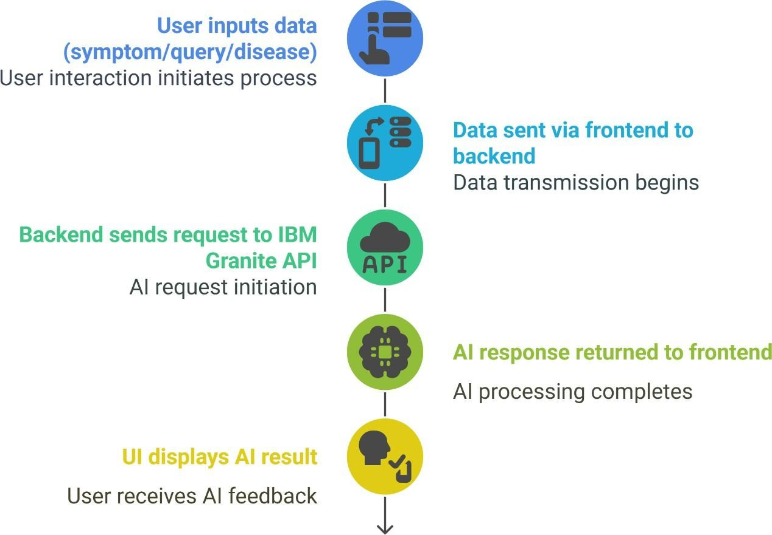

**User Stories**

**1. Symptom Analysis**

As a user, I want to enter my symptoms in my preferred language, so that I can get a possible diagnosis or condition suggestion in a language I understand.  
Acceptance Criteria:

* The system accepts symptom input in any language.
* The system translates the input to English.
* The system returns a possible condition or diagnosis in a clear, understandable format.

**2. Home Remedies**

As a user, I want to enter the name of a disease in any language and receive natural remedy suggestions, so that I can try safe home treatments.  
Acceptance Criteria:

* The system accepts disease input in any language.
* The system translates the input to English.
* The system returns a list of effective home remedies.

**3. Medication Information**

As a user, I want to know what medications are commonly used for a specific disease, so that I can understand my treatment options.  
Acceptance Criteria:

* The system accepts disease input in any language.
* The system translates the input to English.
* The system returns a list of common medications (OTC or prescribed).

**4. Disease Encyclopedia**

As a user, I want to learn about a disease’s causes, symptoms, prevention, and treatment, so that I can be better informed about my health.  
Acceptance Criteria:

* The system accepts disease input in any language.
* The system translates the input to English.
* The system returns a detailed explanation of the disease.

**5. Patient Chat**

As a user, I want to ask general health questions and receive clear, kind, and informative answers, so that I can get reliable health information.  
Acceptance Criteria:

* The system accepts questions in any language.
* The system translates the input to English.
* The system returns a clear, empathetic, and informative response.